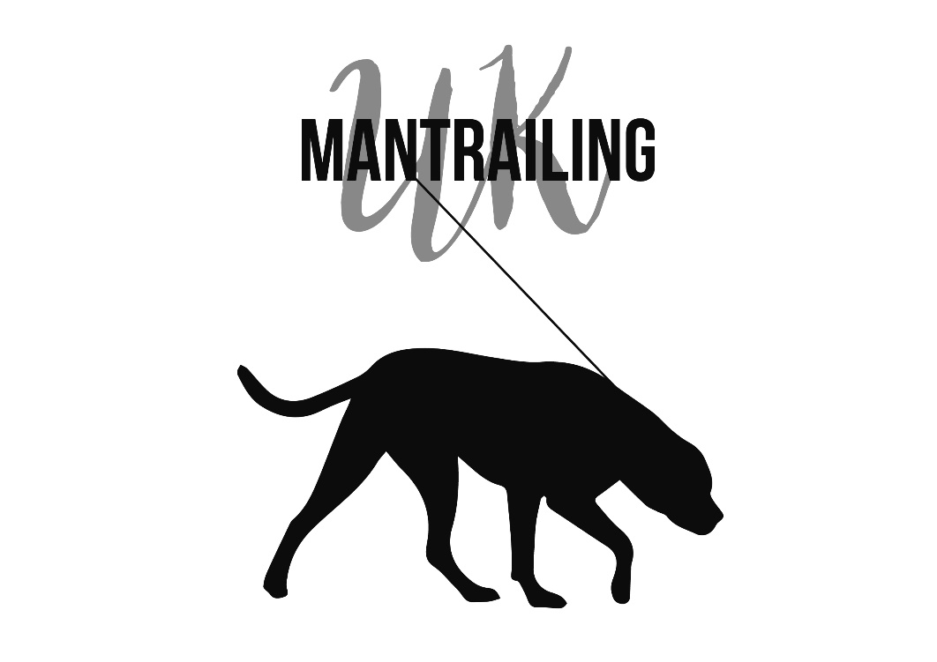
Training and Assessment Log Book
Level 1

Dog handler:____________
Dog:_____________

Training Logbook
1 Location: |  | Date: | Time:
Weather (incl wind movement) | Area details
 | General description of area
Drawing of trail | Ground surface and it´s condition
DETAILS OF TRAINING CARRIED OUT
For each exercise, include details of dogs’ behaviour, list scents, articles, bodies used anything unusual. List Progress/Regress

Trainers comments and signature

2 Location: |  | Date: | Time:
Weather (incl wind movement) | Area details
 | General description of area
Drawing of trail | Ground surface and it´s condition
DETAILS OF TRAINING CARRIED OUT
For each exercise, include details of dogs’ behaviour, list scents, articles, bodies used anything unusual. List Progress/Regress

Trainers comments and signature

3 Location: |  | Date: | Time:
Weather (incl wind movement) | Area details
 | General description of area
Drawing of trail | Ground surface and it´s condition
DETAILS OF TRAINING CARRIED OUT
For each exercise, include details of dogs’ behaviour, list scents, articles, bodies used anything unusual. List Progress/Regress

Trainers comments and signature

4 Location: |  | Date: | Time:
Weather (incl wind movement) | Area details
 | General description of area
Drawing of trail | Ground surface and it´s condition
DETAILS OF TRAINING CARRIED OUT
For each exercise, include details of dogs’ behaviour, list scents, articles, bodies used anything unusual. List Progress/Regress

Trainers comments and signature

5 Location: |  | Date: | Time:
Weather (incl wind movement) | Area details
 | General description of area
Drawing of trail | Ground surface and it´s condition
DETAILS OF TRAINING CARRIED OUT
For each exercise, include details of dogs’ behaviour, list scents, articles, bodies used anything unusual. List Progress/Regress

Trainers comments and signature

6 Location: |  | Date: | Time:
Weather (incl wind movement) | Area details
 | General description of area
Drawing of trail | Ground surface and it´s condition
DETAILS OF TRAINING CARRIED OUT
For each exercise, include details of dogs’ behaviour, list scents, articles, bodies used anything unusual. List Progress/Regress

Trainers comments and signature

7 Location: |  | Date: | Time:
Weather (incl wind movement) | Area details
 | General description of area
Drawing of trail | Ground surface and it´s condition
DETAILS OF TRAINING CARRIED OUT
For each exercise, include details of dogs’ behaviour, list scents, articles, bodies used anything unusual. List Progress/Regress

Trainers comments and signature

8 Location: |  | Date: | Time:
Weather (incl wind movement) | Area details
 | General description of area
Drawing of trail | Ground surface and it´s condition
DETAILS OF TRAINING CARRIED OUT
For each exercise, include details of dogs’ behaviour, list scents, articles, bodies used anything unusual. List Progress/Regress

Trainers comments and signature

9 Location: |  | Date: | Time:
Weather (incl wind movement) | Area details
 | General description of area
Drawing of trail | Ground surface and it´s condition
DETAILS OF TRAINING CARRIED OUT
For each exercise, include details of dogs’ behaviour, list scents, articles, bodies used anything unusual. List Progress/Regress

Trainers comments and signature

10 Location: |  | Date: | Time:
Weather (incl wind movement) | Area details
 | General description of area
Drawing of trail | Ground surface and it´s condition
DETAILS OF TRAINING CARRIED OUT
For each exercise, include details of dogs’ behaviour, list scents, articles, bodies used anything unusual. List Progress/Regress

Trainers comments and signature

11 Location: |  | Date: | Time:
Weather (incl wind movement) | Area details
 | General description of area
Drawing of trail | Ground surface and it´s condition
DETAILS OF TRAINING CARRIED OUT
For each exercise, include details of dogs’ behaviour, list scents, articles, bodies used anything unusual. List Progress/Regress

Trainers comments and signature

12 Location: |  | Date: | Time:
Weather (incl wind movement) | Area details
 | General description of area
Drawing of trail | Ground surface and it´s condition
DETAILS OF TRAINING CARRIED OUT
For each exercise, include details of dogs’ behaviour, list scents, articles, bodies used anything unusual. List Progress/Regress

Trainers comments and signature

13 Location: |  | Date: | Time:
Weather (incl wind movement) | Area details
 | General description of area
Drawing of trail | Ground surface and it´s condition
DETAILS OF TRAINING CARRIED OUT
For each exercise, include details of dogs’ behaviour, list scents, articles, bodies used anything unusual. List Progress/Regress

Trainers comments and signature

14 Location: |  | Date: | Time:
Weather (incl wind movement) | Area details
 | General description of area
Drawing of trail | Ground surface and it´s condition
DETAILS OF TRAINING CARRIED OUT
For each exercise, include details of dogs’ behaviour, list scents, articles, bodies used anything unusual. List Progress/Regress

Trainers comments and signature

15 Location: |  | Date: | Time:
Weather (incl wind movement) | Area details
 | General description of area
Drawing of trail | Ground surface and it´s condition
DETAILS OF TRAINING CARRIED OUT
For each exercise, include details of dogs’ behaviour, list scents, articles, bodies used anything unusual. List Progress/Regress

Trainers comments and signature

16 Location: |  | Date: | Time:
Weather (incl wind movement) | Area details
 | General description of area
Drawing of trail | Ground surface and it´s condition
DETAILS OF TRAINING CARRIED OUT
For each exercise, include details of dogs’ behaviour, list scents, articles, bodies used anything unusual. List Progress/Regress

Trainers comments and signature

17 Location: |  | Date: | Time:
Weather (incl wind movement) | Area details
 | General description of area
Drawing of trail | Ground surface and it´s condition
DETAILS OF TRAINING CARRIED OUT
For each exercise, include details of dogs’ behaviour, list scents, articles, bodies used anything unusual. List Progress/Regress

Trainers comments and signature

18 Location: |  | Date: | Time:
Weather (incl wind movement) | Area details
 | General description of area
Drawing of trail | Ground surface and it´s condition
DETAILS OF TRAINING CARRIED OUT
For each exercise, include details of dogs’ behaviour, list scents, articles, bodies used anything unusual. List Progress/Regress

Trainers comments and signature

19 Location: |  | Date: | Time:
Weather (incl wind movement) | Area details
 | General description of area
Drawing of trail | Ground surface and it´s condition
DETAILS OF TRAINING CARRIED OUT
For each exercise, include details of dogs’ behaviour, list scents, articles, bodies used anything unusual. List Progress/Regress

Trainers comments and signature

20 Location: |  | Date: | Time:
Weather (incl wind movement) | Area details
 | General description of area
Drawing of trail | Ground surface and it´s condition
DETAILS OF TRAINING CARRIED OUT
For each exercise, include details of dogs’ behaviour, list scents, articles, bodies used anything unusual. List Progress/Regress

Trainers comments and signature

Level 1 - Assessment
Criteria:
- Single blind
- Trail length: 200-400m
- 1 change of direction (90 degrees)
- Age of trail: 30 min – 1hr
- Max. 30 min to find Misper
- Terrain: Forestry, Field, Field walks, rural
- 1 Missing person, sitting/laying/standing
- 1 Flanker allowed
Name of Dog
Date of Assessment

Assessor

Trail layer

Passed

Please note that Mantrailing UK Ltd or any associated instructors, cannot be held accountable for any failed assessments.

