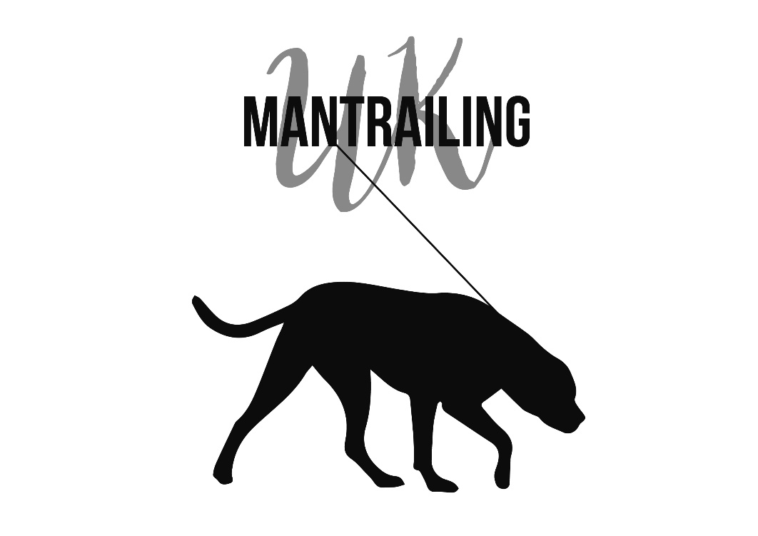
Training and Assessment Log Book
Level 3

Dog handler:____________
Dog:_____________

Training Logbook
1 Location: |  | Date: | Time:
Weather (incl wind movement) | Area details
 | General description of area
Drawing of trail | Ground surface and it´s condition
DETAILS OF TRAINING CARRIED OUT
For each exercise, include details of dogs’ behaviour, list scents, articles, bodies used anything unusual. List Progress/Regress

Trainers comments and signature

2 Location: |  | Date: | Time:
Weather (incl wind movement) | Area details
 | General description of area
Drawing of trail | Ground surface and it´s condition
DETAILS OF TRAINING CARRIED OUT
For each exercise, include details of dogs’ behaviour, list scents, articles, bodies used anything unusual. List Progress/Regress

Trainers comments and signature

3 Location: |  | Date: | Time:
Weather (incl wind movement) | Area details
 | General description of area
Drawing of trail | Ground surface and it´s condition
DETAILS OF TRAINING CARRIED OUT
For each exercise, include details of dogs’ behaviour, list scents, articles, bodies used anything unusual. List Progress/Regress

Trainers comments and signature

4 Location: |  | Date: | Time:
Weather (incl wind movement) | Area details
 | General description of area
Drawing of trail | Ground surface and it´s condition
DETAILS OF TRAINING CARRIED OUT
For each exercise, include details of dogs’ behaviour, list scents, articles, bodies used anything unusual. List Progress/Regress

Trainers comments and signature

5 Location: |  | Date: | Time:
Weather (incl wind movement) | Area details
 | General description of area
Drawing of trail | Ground surface and it´s condition
DETAILS OF TRAINING CARRIED OUT
For each exercise, include details of dogs’ behaviour, list scents, articles, bodies used anything unusual. List Progress/Regress

Trainers comments and signature

6 Location: |  | Date: | Time:
Weather (incl wind movement) | Area details
 | General description of area
Drawing of trail | Ground surface and it´s condition
DETAILS OF TRAINING CARRIED OUT
For each exercise, include details of dogs’ behaviour, list scents, articles, bodies used anything unusual. List Progress/Regress

Trainers comments and signature

7 Location: |  | Date: | Time:
Weather (incl wind movement) | Area details
 | General description of area
Drawing of trail | Ground surface and it´s condition
DETAILS OF TRAINING CARRIED OUT
For each exercise, include details of dogs’ behaviour, list scents, articles, bodies used anything unusual. List Progress/Regress

Trainers comments and signature

8 Location: |  | Date: | Time:
Weather (incl wind movement) | Area details
 | General description of area
Drawing of trail | Ground surface and it´s condition
DETAILS OF TRAINING CARRIED OUT
For each exercise, include details of dogs’ behaviour, list scents, articles, bodies used anything unusual. List Progress/Regress

Trainers comments and signature

9 Location: |  | Date: | Time:
Weather (incl wind movement) | Area details
 | General description of area
Drawing of trail | Ground surface and it´s condition
DETAILS OF TRAINING CARRIED OUT
For each exercise, include details of dogs’ behaviour, list scents, articles, bodies used anything unusual. List Progress/Regress

Trainers comments and signature

10 Location: |  | Date: | Time:
Weather (incl wind movement) | Area details
 | General description of area
Drawing of trail | Ground surface and it´s condition
DETAILS OF TRAINING CARRIED OUT
For each exercise, include details of dogs’ behaviour, list scents, articles, bodies used anything unusual. List Progress/Regress

Trainers comments and signature

11 Location: |  | Date: | Time:
Weather (incl wind movement) | Area details
 | General description of area
Drawing of trail | Ground surface and it´s condition
DETAILS OF TRAINING CARRIED OUT
For each exercise, include details of dogs’ behaviour, list scents, articles, bodies used anything unusual. List Progress/Regress

Trainers comments and signature

12 Location: |  | Date: | Time:
Weather (incl wind movement) | Area details
 | General description of area
Drawing of trail | Ground surface and it´s condition
DETAILS OF TRAINING CARRIED OUT
For each exercise, include details of dogs’ behaviour, list scents, articles, bodies used anything unusual. List Progress/Regress

Trainers comments and signature

13 Location: |  | Date: | Time:
Weather (incl wind movement) | Area details
 | General description of area
Drawing of trail | Ground surface and it´s condition
DETAILS OF TRAINING CARRIED OUT
For each exercise, include details of dogs’ behaviour, list scents, articles, bodies used anything unusual. List Progress/Regress

Trainers comments and signature

14 Location: |  | Date: | Time:
Weather (incl wind movement) | Area details
 | General description of area
Drawing of trail | Ground surface and it´s condition
DETAILS OF TRAINING CARRIED OUT
For each exercise, include details of dogs’ behaviour, list scents, articles, bodies used anything unusual. List Progress/Regress

Trainers comments and signature

15 Location: |  | Date: | Time:
Weather (incl wind movement) | Area details
 | General description of area
Drawing of trail | Ground surface and it´s condition
DETAILS OF TRAINING CARRIED OUT
For each exercise, include details of dogs’ behaviour, list scents, articles, bodies used anything unusual. List Progress/Regress

Trainers comments and signature

16 Location: |  | Date: | Time:
Weather (incl wind movement) | Area details
 | General description of area
Drawing of trail | Ground surface and it´s condition
DETAILS OF TRAINING CARRIED OUT
For each exercise, include details of dogs’ behaviour, list scents, articles, bodies used anything unusual. List Progress/Regress

Trainers comments and signature

17 Location: |  | Date: | Time:
Weather (incl wind movement) | Area details
 | General description of area
Drawing of trail | Ground surface and it´s condition
DETAILS OF TRAINING CARRIED OUT
For each exercise, include details of dogs’ behaviour, list scents, articles, bodies used anything unusual. List Progress/Regress

Trainers comments and signature

18 Location: |  | Date: | Time:
Weather (incl wind movement) | Area details
 | General description of area
Drawing of trail | Ground surface and it´s condition
DETAILS OF TRAINING CARRIED OUT
For each exercise, include details of dogs’ behaviour, list scents, articles, bodies used anything unusual. List Progress/Regress

Trainers comments and signature

19 Location: |  | Date: | Time:
Weather (incl wind movement) | Area details
 | General description of area
Drawing of trail | Ground surface and it´s condition
DETAILS OF TRAINING CARRIED OUT
For each exercise, include details of dogs’ behaviour, list scents, articles, bodies used anything unusual. List Progress/Regress

Trainers comments and signature

20 Location: |  | Date: | Time:
Weather (incl wind movement) | Area details
 | General description of area
Drawing of trail | Ground surface and it´s condition
DETAILS OF TRAINING CARRIED OUT
For each exercise, include details of dogs’ behaviour, list scents, articles, bodies used anything unusual. List Progress/Regress

Trainers comments and signature

21 Location: |  | Date: | Time:
Weather (incl wind movement) | Area details
 | General description of area
Drawing of trail | Ground surface and it´s condition
DETAILS OF TRAINING CARRIED OUT
For each exercise, include details of dogs’ behaviour, list scents, articles, bodies used anything unusual. List Progress/Regress

Trainers comments and signature

22 Location: |  | Date: | Time:
Weather (incl wind movement) | Area details
 | General description of area
Drawing of trail | Ground surface and it´s condition
DETAILS OF TRAINING CARRIED OUT
For each exercise, include details of dogs’ behaviour, list scents, articles, bodies used anything unusual. List Progress/Regress

Trainers comments and signature

23 Location: |  | Date: | Time:
Weather (incl wind movement) | Area details
 | General description of area
Drawing of trail | Ground surface and it´s condition
DETAILS OF TRAINING CARRIED OUT
For each exercise, include details of dogs’ behaviour, list scents, articles, bodies used anything unusual. List Progress/Regress

Trainers comments and signature

24 Location: |  | Date: | Time:
Weather (incl wind movement) | Area details
 | General description of area
Drawing of trail | Ground surface and it´s condition
DETAILS OF TRAINING CARRIED OUT
For each exercise, include details of dogs’ behaviour, list scents, articles, bodies used anything unusual. List Progress/Regress

Trainers comments and signature

25 Location: |  | Date: | Time:
Weather (incl wind movement) | Area details
 | General description of area
Drawing of trail | Ground surface and it´s condition
DETAILS OF TRAINING CARRIED OUT
For each exercise, include details of dogs’ behaviour, list scents, articles, bodies used anything unusual. List Progress/Regress

Trainers comments and signature

26 Location: |  | Date: | Time:
Weather (incl wind movement) | Area details
 | General description of area
Drawing of trail | Ground surface and it´s condition
DETAILS OF TRAINING CARRIED OUT
For each exercise, include details of dogs’ behaviour, list scents, articles, bodies used anything unusual. List Progress/Regress

Trainers comments and signature

27 Location: |  | Date: | Time:
Weather (incl wind movement) | Area details
 | General description of area
Drawing of trail | Ground surface and it´s condition
DETAILS OF TRAINING CARRIED OUT
For each exercise, include details of dogs’ behaviour, list scents, articles, bodies used anything unusual. List Progress/Regress

Trainers comments and signature

28 Location: |  | Date: | Time:
Weather (incl wind movement) | Area details
 | General description of area
Drawing of trail | Ground surface and it´s condition
DETAILS OF TRAINING CARRIED OUT
For each exercise, include details of dogs’ behaviour, list scents, articles, bodies used anything unusual. List Progress/Regress

Trainers comments and signature

29 Location: |  | Date: | Time:
Weather (incl wind movement) | Area details
 | General description of area
Drawing of trail | Ground surface and it´s condition
DETAILS OF TRAINING CARRIED OUT
For each exercise, include details of dogs’ behaviour, list scents, articles, bodies used anything unusual. List Progress/Regress

Trainers comments and signature

30 Location: |  | Date: | Time:
Weather (incl wind movement) | Area details
 | General description of area
Drawing of trail | Ground surface and it´s condition
DETAILS OF TRAINING CARRIED OUT
For each exercise, include details of dogs’ behaviour, list scents, articles, bodies used anything unusual. List Progress/Regress

Trainers comments and signature

31 Location: |  | Date: | Time:
Weather (incl wind movement) | Area details
 | General description of area
Drawing of trail | Ground surface and it´s condition
DETAILS OF TRAINING CARRIED OUT
For each exercise, include details of dogs’ behaviour, list scents, articles, bodies used anything unusual. List Progress/Regress

Trainers comments and signature

32 Location: |  | Date: | Time:
Weather (incl wind movement) | Area details
 | General description of area
Drawing of trail | Ground surface and it´s condition
DETAILS OF TRAINING CARRIED OUT
For each exercise, include details of dogs’ behaviour, list scents, articles, bodies used anything unusual. List Progress/Regress

Trainers comments and signature

33 Location: |  | Date: | Time:
Weather (incl wind movement) | Area details
 | General description of area
Drawing of trail | Ground surface and it´s condition
DETAILS OF TRAINING CARRIED OUT
For each exercise, include details of dogs’ behaviour, list scents, articles, bodies used anything unusual. List Progress/Regress

Trainers comments and signature

34 Location: |  | Date: | Time:
Weather (incl wind movement) | Area details
 | General description of area
Drawing of trail | Ground surface and it´s condition
DETAILS OF TRAINING CARRIED OUT
For each exercise, include details of dogs’ behaviour, list scents, articles, bodies used anything unusual. List Progress/Regress

Trainers comments and signature

35 Location: |  | Date: | Time:
Weather (incl wind movement) | Area details
 | General description of area
Drawing of trail | Ground surface and it´s condition
DETAILS OF TRAINING CARRIED OUT
For each exercise, include details of dogs’ behaviour, list scents, articles, bodies used anything unusual. List Progress/Regress

Trainers comments and signature

36 Location: |  | Date: | Time:
Weather (incl wind movement) | Area details
 | General description of area
Drawing of trail | Ground surface and it´s condition
DETAILS OF TRAINING CARRIED OUT
For each exercise, include details of dogs’ behaviour, list scents, articles, bodies used anything unusual. List Progress/Regress

Trainers comments and signature

37 Location: |  | Date: | Time:
Weather (incl wind movement) | Area details
 | General description of area
Drawing of trail | Ground surface and it´s condition
DETAILS OF TRAINING CARRIED OUT
For each exercise, include details of dogs’ behaviour, list scents, articles, bodies used anything unusual. List Progress/Regress

Trainers comments and signature

38 Location: |  | Date: | Time:
Weather (incl wind movement) | Area details
 | General description of area
Drawing of trail | Ground surface and it´s condition
DETAILS OF TRAINING CARRIED OUT
For each exercise, include details of dogs’ behaviour, list scents, articles, bodies used anything unusual. List Progress/Regress

Trainers comments and signature

39 Location: |  | Date: | Time:
Weather (incl wind movement) | Area details
 | General description of area
Drawing of trail | Ground surface and it´s condition
DETAILS OF TRAINING CARRIED OUT
For each exercise, include details of dogs’ behaviour, list scents, articles, bodies used anything unusual. List Progress/Regress

Trainers comments and signature

40 Location: |  | Date: | Time:
Weather (incl wind movement) | Area details
 | General description of area
Drawing of trail | Ground surface and it´s condition
DETAILS OF TRAINING CARRIED OUT
For each exercise, include details of dogs’ behaviour, list scents, articles, bodies used anything unusual. List Progress/Regress

Trainers comments and signature

41 Location: |  | Date: | Time:
Weather (incl wind movement) | Area details
 | General description of area
Drawing of trail | Ground surface and it´s condition
DETAILS OF TRAINING CARRIED OUT
For each exercise, include details of dogs’ behaviour, list scents, articles, bodies used anything unusual. List Progress/Regress

Trainers comments and signature

42 Location: |  | Date: | Time:
Weather (incl wind movement) | Area details
 | General description of area
Drawing of trail | Ground surface and it´s condition
DETAILS OF TRAINING CARRIED OUT
For each exercise, include details of dogs’ behaviour, list scents, articles, bodies used anything unusual. List Progress/Regress

Trainers comments and signature

43 Location: |  | Date: | Time:
Weather (incl wind movement) | Area details
 | General description of area
Drawing of trail | Ground surface and it´s condition
DETAILS OF TRAINING CARRIED OUT
For each exercise, include details of dogs’ behaviour, list scents, articles, bodies used anything unusual. List Progress/Regress

Trainers comments and signature

44 Location: |  | Date: | Time:
Weather (incl wind movement) | Area details
 | General description of area
Drawing of trail | Ground surface and it´s condition
DETAILS OF TRAINING CARRIED OUT
For each exercise, include details of dogs’ behaviour, list scents, articles, bodies used anything unusual. List Progress/Regress

Trainers comments and signature

45 Location: |  | Date: | Time:
Weather (incl wind movement) | Area details
 | General description of area
Drawing of trail | Ground surface and it´s condition
DETAILS OF TRAINING CARRIED OUT
For each exercise, include details of dogs’ behaviour, list scents, articles, bodies used anything unusual. List Progress/Regress

Trainers comments and signature

Level 3 - Assessment
Criteria:
- Double blind
- Trail length: 600-1000m
- 2 changes of direction (90 degrees)
- Age of trail: 2-4hrs
- Max. 45 min to find Misper
- Terrain: urban, rural, industrial, mixture of terrains
- 2 Mispers, sitting/laying/standing – dog needs to identify the right Misper
- 1 Flanker allowed
Name of Dog
Date of Assessment

Assessor

Trail layer

Passed

Please note that Mantrailing UK Ltd or any associated instructors, cannot be held accountable for any failed assessments.

